**Hide Apache Version on ubuntu linux**

**Preparation -**

1. **Login to server**
2. **Take a backup security.conf file**

$ cp /etc/apache2/conf-available/security.conf /etc/apache2/conf-available/security_date.conf

**2. Open the Apache configuration file using your preferred text editor. The default file location is**

$ vim /etc/apache2/conf-available/security.conf

**3. Add the following lines to the file:**

ServerTokens Prod

ServerSignature Off

Save the file and exit the text editor.

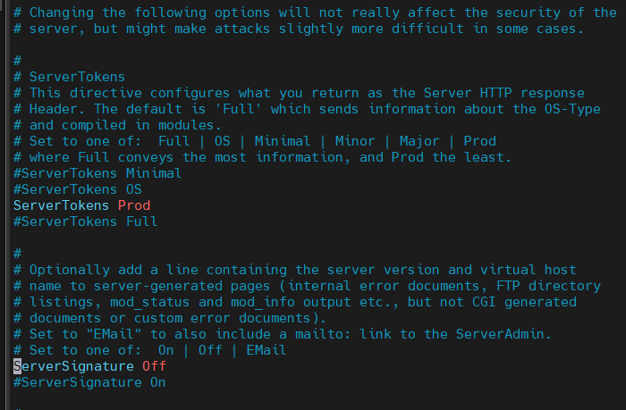

**4. Restart Apache using the command**

$ sudo systemctl restart apache2.

**Testing:-**

URL :- [https://](https://ulr)url.com

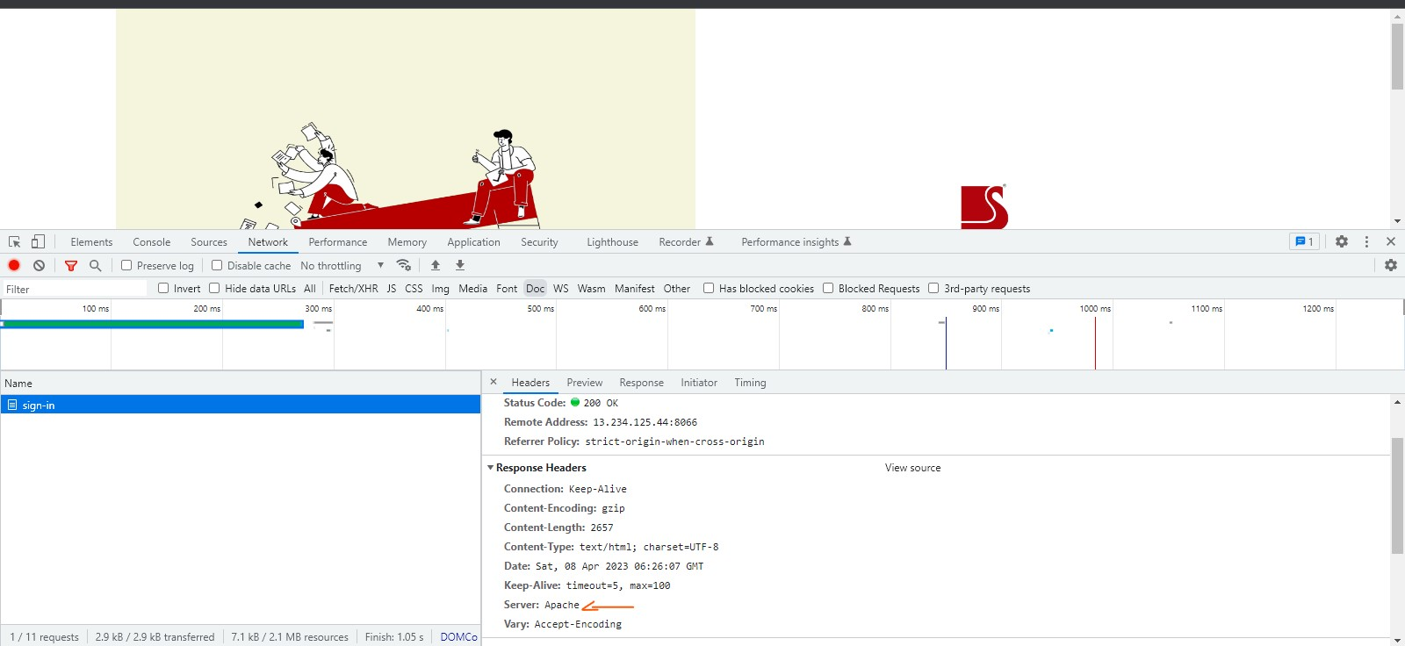

These lines modify the Apache configuration to use the "Prod" setting for the "ServerTokens" directive, which will suppress the Apache version number in the server response headers. The "ServerSignature Off" directive will disable the server signature that includes the server name and version in error messages.